BIRLA INSTITUTE OF TECHNOLOGY & SCIENCE, PILANI
First Semester (2023-24)
Assignment-4

Q1). In a certain material under load, plane AB carries a tensile direct stress of 30 MPa and a shear and a shear of 20 MPa, while another plane BC carries a tensile direct stress of 20 MPa and a shear stress. If the planes are inclined to one another at 30⁰ and plane AC at right angles to plane AB carries a direct stress unknown in magnitude and nature, find (a) the value of the shear stress on BC, (b) the magnitude and nature of the direct stress on AC, and (c) the principle stresses (Fig. 1).
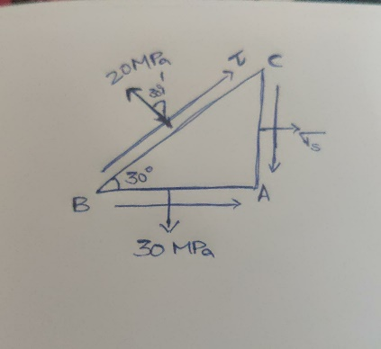

(Fig. 1)

Q2). A mild steel plate is stressed as shown in a figure. Before stressing, a circle of 300mm diameter is drawn on the plate. Take poisons ratio = 0.3; Modulus of elasticity = 200GN/mm² (Fig. 2).

Determine:
- The principal stresses developed in MPa respectively.
- The lengths of the major and minor axes, in mm, of the ellipse into which the circle deforms after stressing.

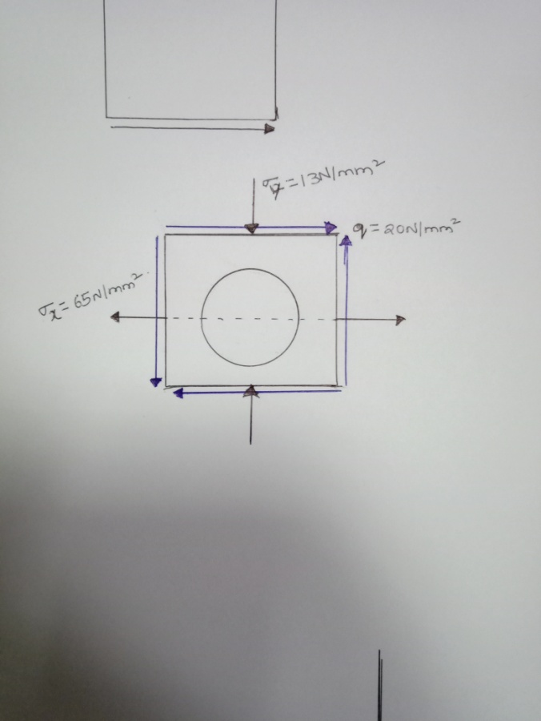

(Fig. 2)

Q3). At a point in a loaded components the state of stress is given by σ_{x} = 270 MPa, σ_{y} = 130MPa
and τ_{xy} = ±40MPa. Determine:
- The maximum and minimum principal stresses and the planes on which they act.
- The maximum shearing stress in magnitude and direction.

Q4). Two members of uniform cross section 50 x 80 mm are glued together along plane a-a that forms and angle of 25⁰ with the horizontal. Knowing the allowable stresses for the glue joint are σ = 800KPa and τ = 600KPa, determine the largest centric load P that can be applied (Fig. 3).
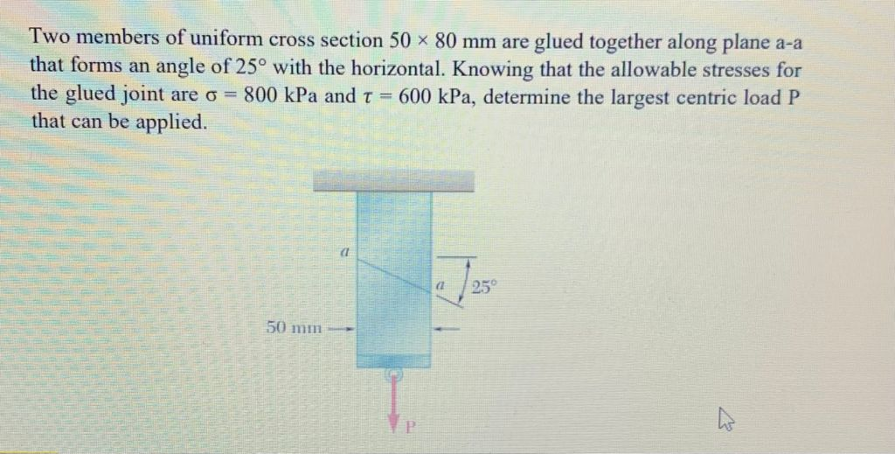

(Fig. 3)

Q5). On a mild steel plate, a circle of diameter 50mm is drawn before the plate is stressed as shown in the below fig. Find the lengths of the major and minor axes of the ellipse formed due to deformed of circle marked. Take E =200GPa and 1/m =1/4 (Fig. 4)
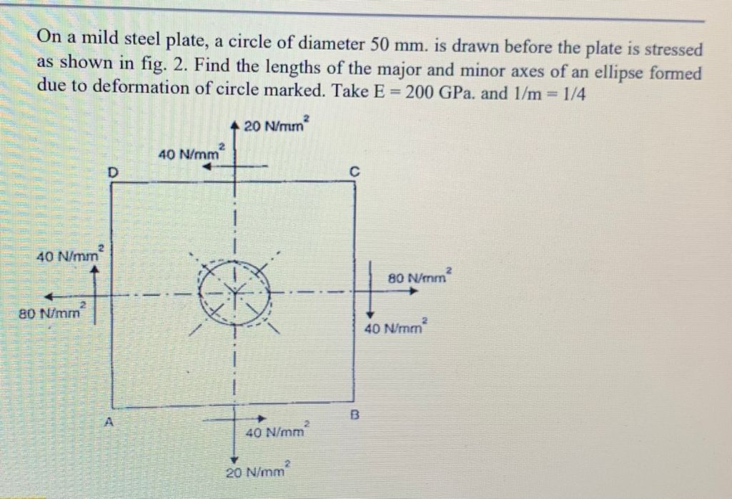

(Fig. 4)

